Assignment 4

**Task 1: A Mesh Convergence Study**

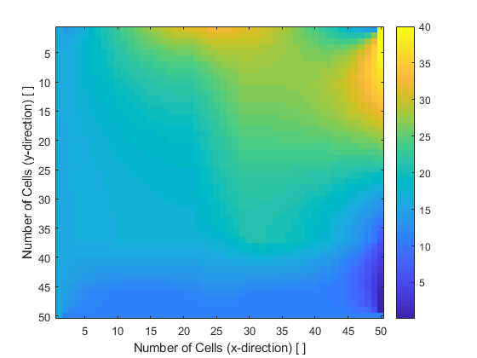

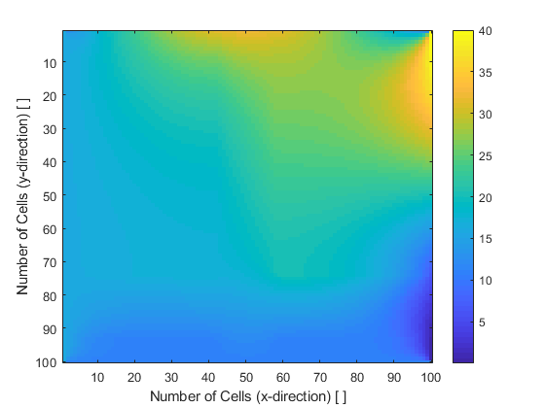

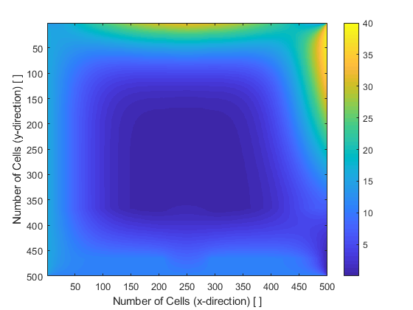

**Task 2: A Contour Plot of Temperature – Temperature in Celcius**

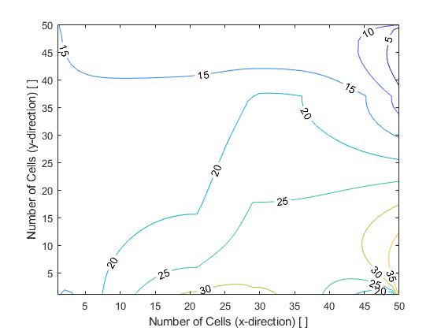

**Task 3: A 3D Color Plot of Temperature**

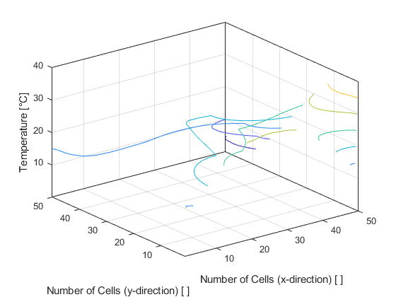

**Task 4: A Vector Plot of the Heat Flux – Shows Direction**

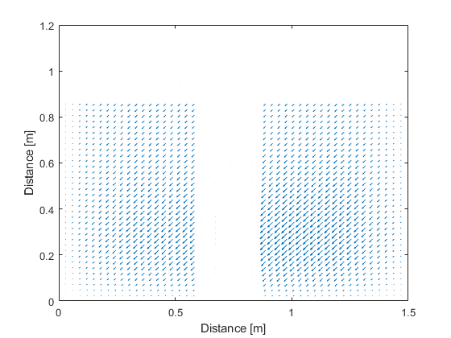

**Task 5: A Heat Flux 3D Color Plot**

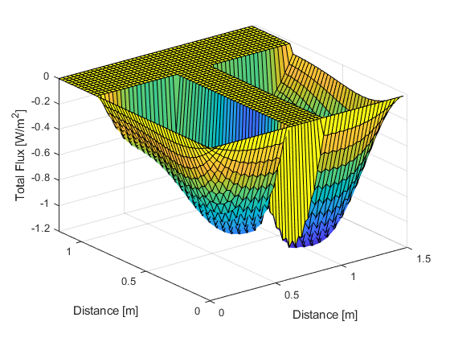

**Task 6: Two Additional Plots**

**Plot 1: Color Plot of Total Flux at Iteration 200 – Heat Flux in W/ $m^{2}$**

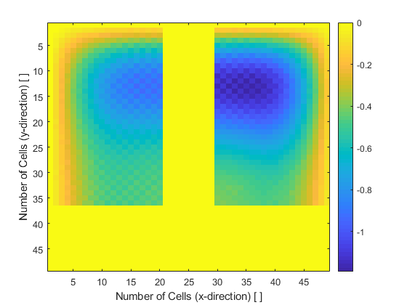

**Plot 2: How Iterations Affect the Result – (50, 500 and 5,000 Iterations)**

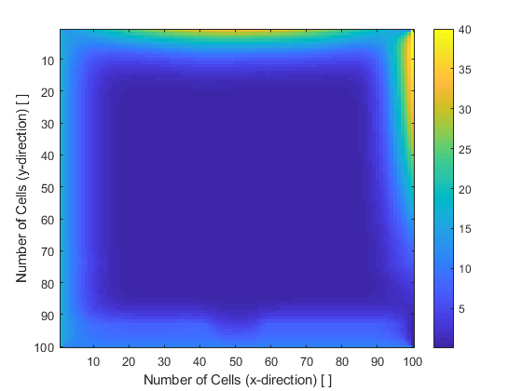

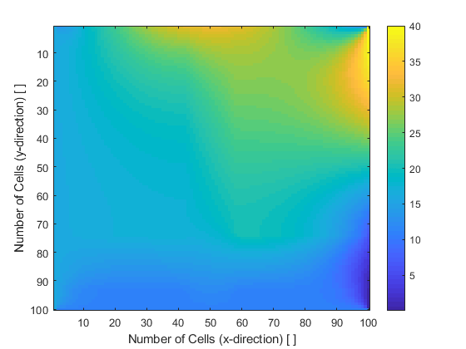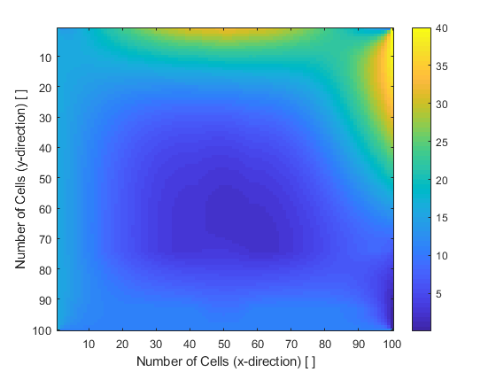

**Task 7: A 3D Color Plot of Temperature with a Modified BC**

